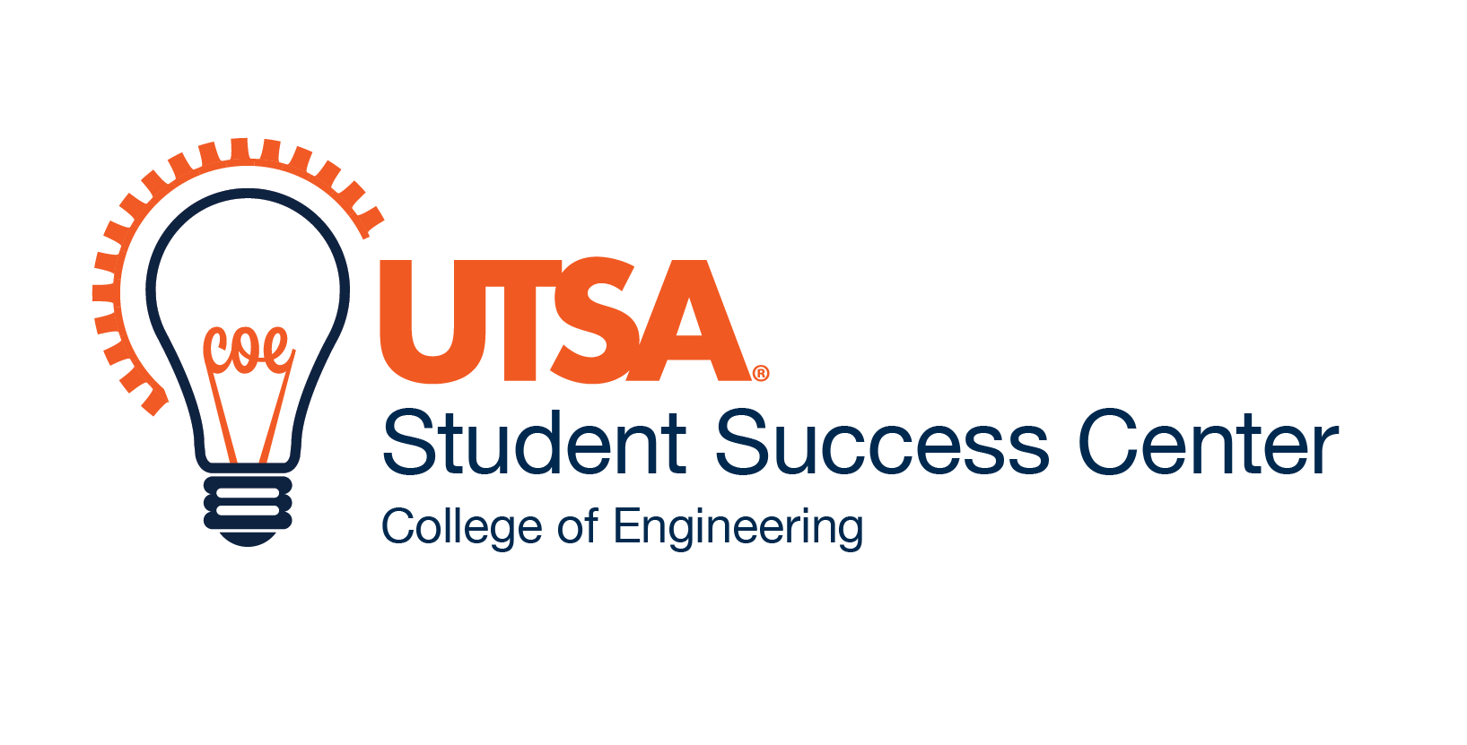
Student Success Center Use Only

___ Approved ____Denied

Undergraduate Research Program
Application Form (Student)

Date: | Semester Requested: Spring Summer Fall

Student Information:
Name (Last, First) |  |  |  |  |  |  |  | Banner ID
Address |  |  |  |  | City |  |  |  | State |  | Zip
Phone |  |  |  | Email
Current GPA |  |  |  | Year |  | FR SO JR SR Other
Engineering Department
Biomedical  Chemical  Civil |  |  | Electrical and Computer  Mechanical
Faculty Mentor (Last, First)

Research Project Information:
(Brief, handwritten statements and/or attachments are acceptable)
Research Interest Area(s):

Long Term Goals (graduate school, career, type of employment, etc.):

I hereby give permission for my name to be published as an Undergraduate Research Scholar on University websites and I agree to participate in the UTSA Undergraduate Research & Creative Inquiry Showcase.

Student Signature Date

Undergraduate Research Program
Application Form (Faculty)
Date:

Faculty Mentor Information:
Name (Last, First) |  |  |  |  | Cost Center Account #
Phone |  |  | Email
Engineering Department
Biomedical  Chemical  Civil |  | Electrical and Computer  Mechanical
Student Name (First Last):

Research Project Information:
(Brief, handwritten statements and/or attachments are acceptable)
Title of Research Project:

Research Project (general area of research, specific role for the undergraduate research student, your long term vision for this research, potential for attracting the student to graduate program, or any information you feel would be helpful):

(If additional space is needed, please attach a separate piece of paper)
I am authorized and agree to provide $500 of matching funds from the above indicated Cost Center Account.

_____________________________ _______________________________ _________________
Faculty Mentor (Printed) Signature Date

______________________________ ________________________________ _________________
Department Chairman (Printed) Signature Date
Submit with completed Student application to Engineering Student Success Center

